Common Elements

The elements all have different symbols. Symbols may be either one letter (written as capitals) or two (the first letter is a capital and the second letter is always lower-case).

Aluminium Al
Barium Ba
Bromine Br
Calcium Ca
Carbon C
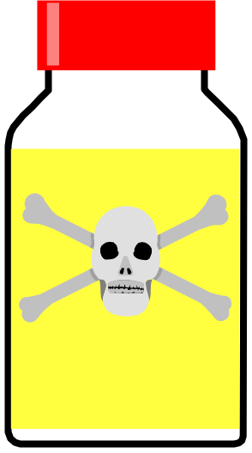Chlorine Cl
Copper Cu
Flourine F
Gold Au
Hydrogen H
Iodine I
Iron Fe
Lead Pb
Magnesium Mg
Manganese Mn
Mercury Hg
Nickel Ni
Nitrogen N
Oxygen O
Potassium K
Silver Ag
Sodium Na
Sulphur S
Tin Sn
Uranium U
Zinc Zn

You must try and learn the above elements and their symbols. You will be quizzed on them regularly.

